Bunker Permission, Checklist & Declaration Form
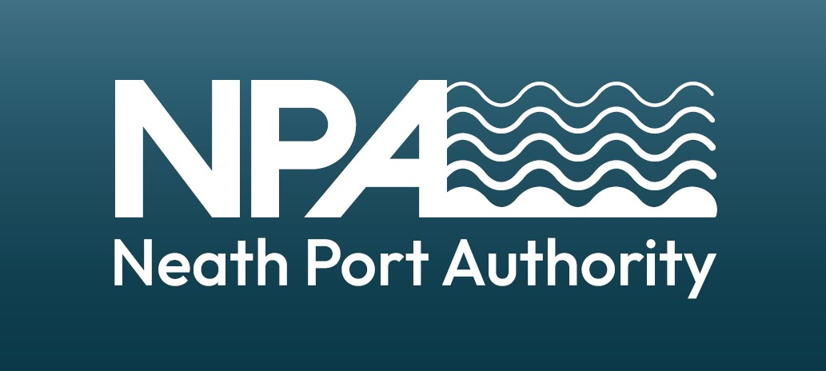

Contact Neath Harbour Master harbourmasterneath@outlook.com to request permission to undertake bunkering transfer.

Part A: Request permission to carry out the transfer of bunkers at all wharfs at the port of Neath

Vessel:
Berth
Agent:
Name of company carrying out the Transfer:
Type/s of bunkers to transfer:
Quantity (m3) of bunkers to transfer:
Road Tanker or Ship/Barge Transfer: |  | Road or Ship/Barge (delete as required)
Proposed start & completion times: |  | Start: | Finish:
Delivery vehicle registration:

Permission Granted | Yes or No (delete as required)
Date and Time:
Reason for Refusal:

Part B: Checklist to be Completed Immediately Prior to Bunkering when permission is given

Task | Yes | No
Part A Completed and Bunkering Authorised
Code flag ‘B’ or red light displayed
Sufficient tank capacity and existing contents of tanks known
Transfer hoses and connections inspected and in good condition
Suitable firefighting equipment in place
Pollution control equipment ready for immediate use
Emergency stop fitted to transfer pump and tested
Deck scuppers plugged
Safe means of access between vessels/shore
No smoking notices displayed
Drip trays/save-alls positioned
Adequate fendering between vessels (ship to ship only)
All unused bunker connections blanked and fully isolated
Effective communication between ship and supplier

Signed by Responsible Person:
Date and Time:

In the event of a spill stop operations immediately and contact Neath Harbour Master on 07983 149 448

Part C: To be Completed Immediately after Bunkering

Check | Yes | No
Quantity and type of bunkers transferred as per Part A (if not see below):
Consignment note or receipt received & attached:

Amendments
Actual type/s transferred:
Actual quantity transferred (m3):

Part D: Declaration

We have completed the Bunker Permission, Checklist and Declaration Form and confirm all declared information is correct to the best of our knowledge.

Name of Master
Signature of Master:
Date and Time:

Please return this completed form and consignment note or receipt to your agent and The Neath Port Authority at harbourmasterneath@outlook.com

